Project Manager

Name: ***Yaroslav Gondarenko***

Address:

Water or electricity bill:

Selfie:

Passport:

Frontend Developer

Name: ***Yevgeniy Rupas***

Address:

Water or electricity bill:

Selfie:

Passport:

Backend Developer

Name:

Address:

Water or electricity bill:

Selfie:

Passport:

Financial Supporter

Name: ***Dmitriy Klyukin***

Address: Uralskih rabochih, 21-52, Ekaterinburg, Russian Federation

Water or electricity bill:

Selfie:

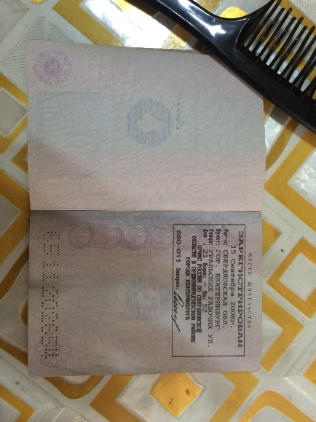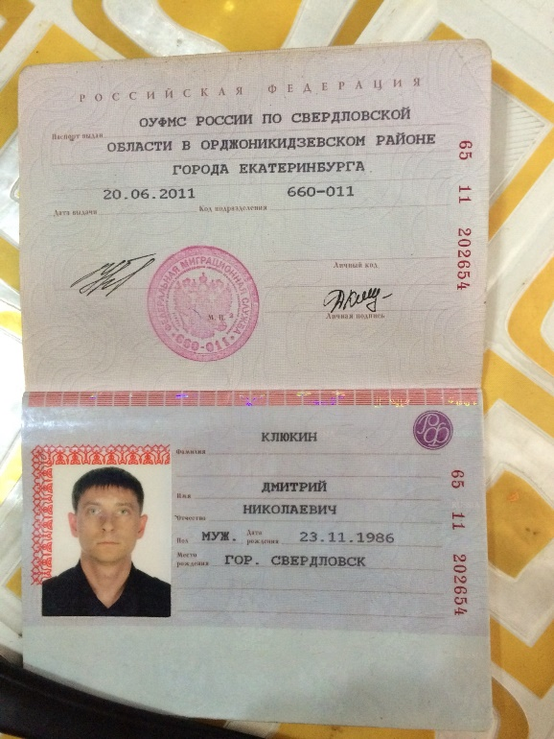Passport: